Mouse Paint- Mixing Secondary Colors GRADE: Kindergarten

STANDARDS: National- 1; SD- 2
OBJECTIVES:
- Practice drawing, cutting, and gluing simple shapes and lines.
- Practice color mixing of primary colors to mix secondary colors.
- Begin learning to transform and combine shapes to form new shapes.
- Review using appropriate amounts of glue.
- Review scissor control.
- Introduce basic brush control and cleaning procedures.

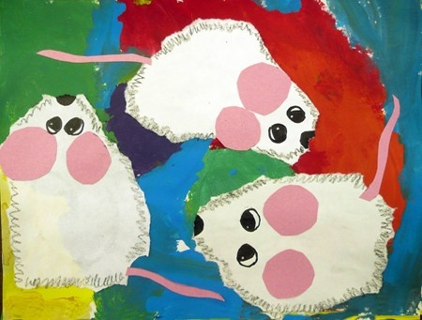
MATERIALS:
- Mouse Paint Book
- 9”x12” or 11”x14” white paper
- Black construction paper to matt white paper
- Black colored pencils
- White squares for mice
- Pink paper for ears/tails
- Scissors/glue
- Paper Plates
- Red, blue, yellow tempera Paint
- Brushes
- Water buckets
- Paper towels

PROCEDURE:
Day 1:
- Read Mouse Paint. Discuss how primary colors mix to make secondary colors. Explain that we will be creating our own mice. Option: can also teach sign language colors as you go through the book.
- Hand out white paper.
- Hand out paint, brushes, water buckets, and paper towels.
- Explain that our brushes are like magic wands. They will help us to mix the colors we need on our blank white paper so that we can hide from the cat.
- Demonstrate mixing a secondary color on paper hung on the board. Lead them step-by-step in putting colors on their paper and when to wash out brush. Always blot brush on paper towel before putting in more paint. Explain that when you want to switch to a new color you MUST wash out your brush very well by rubbing it on the bottom of your bucket otherwise your colors will look muddy if they all mix. Only mix TWO primary colors at a time. Fill the page with all six colors, washing brushes between every color.
- Put pictures on drying rack.
- Demonstrate washing brushes by rubbing in palm of hand under the water until all the color comes out and the water is clean.
- Dump out paint buckets/throw away paper towels.
- Spray tables and have students wipe with paper towels during clean up song/countdown.
Day 2:
- Hand back painted paper to use for background.
- Hand out white paper and guide them through drawing shapes for the mice. (Teardrop shape, eyes, whiskers). Use colored pencils to create a zigzag outline that will give the illusion of fur. Another option is to rip paper shape out and then draw the mouse shape inside.
- Hand out pink paper. Have them cut out circles for ears and the tail. Point out how all these shapes put together create the shape of the mouse.
- Demo gluing on shapes to create mice. Add a black nose and whiskers using colored pencil.

VOCABULARY:
Shape-Triangle, oval, circle, teardrop
Color-primary, secondary
Texture-furry

ASSESSMENT:
- Student can successfully mix primary colors to create secondary colors.
- Student uses painting materials appropriately and neatly.
- Student can draw, cut, and glue various shapes appropriately.

COMMENTS:
_________________________________________________________________________________________________________________________________________________________________________________________________________________________________________________________

ALTERNATE IDEAS/MEDIUMS:
-Watercolor paints
-Draw mice in sharpie first, dancing, and add paint over the top and with puddles underneath
-Collage on a cat peaking over the top of the paper
-Use primary colored model magic to mix colors and to create 3D mice

