Jazzy Line Designs GRADE: 3rd

STANDARDS: National- 5; SD-4

OBJECTIVES:
- Continue to build on fundamentals learned and expand on basic skills and techniques
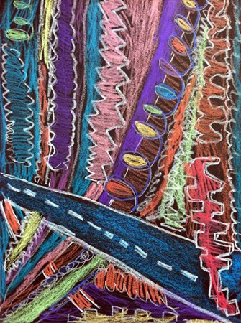
- Reintroduce elements of art: Line (Straight, wavy, zigzag, curved, dotted, looped, dashed, spiral, radiating, diagonal, vertical, horizontal)
- Reintroduce shape: Pattern design

MATERIALS:
- 12”x18” black construction paper
- White Construction paper crayons
- Assorted colors construction paper crayons

PROCEDURE:
- Open smartboard presentation. Talk about how we will be learning about jazzy lines, or lines with personality.
- Brainstorm kinds of lines. Have groups at tables draw as many lines as they know on white boards and then share with class. Have one person from each table come up to the smartboard to share a line their group came up with.
- Have students listen to jazz music from Miles Davis and Louis Armstrong. While they are listening, have them draw lines in the air that corresponds with the tempo and style of the music.
- Demo on smart document camera how to draw various lines using white crayon. Emphasize drawing very bold with the white crayon so it stands out. Instruct them not to cross through lines but to stop when they get to another line.
- Demonstrate coloring in the sections/shapes that are created from the lines using colors of their choosing.
- Allow time for them to come up with their own original designs.

VOCABULARY: Line- straight, wavy, zigzag, curved, dotted, looped, dashed, spiral, radiating, diagonal, vertical, horizontal

ASSESSMENT:
- Student incorporated all the described lines in their compositions.
- Student connected lines to edges of paper and colored inside shapes carefully.
- Student created an interesting and pleasing composition.

OTHER RELATED IDEAS/MEDIUMS: Chalk, oil pastel
COMMENTS:
_______________________________________________________________________________________________________________________________________________________________________________________________________________________________________

