Contour Drawing GRADE: 3rd

STANDARDS: National-1; SD-2
OBJECTIVES:
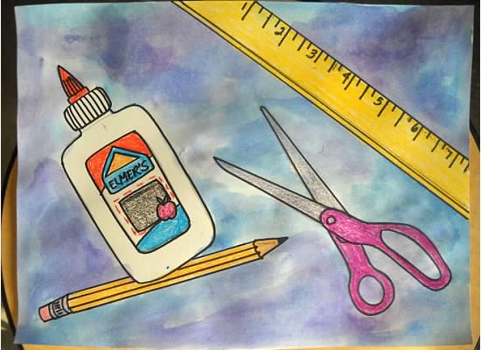
- Practice drawing from observation.
- Identify positive/negative space.
- Continue building on painting techniques.
- Use overlapping in drawing.

MATERIALS:
- 9” x 12” practice paper
- 9” x 12” white drawing paper
- Pencils
- Crayons
- Watercolor paints/brushes
- Art box supplies to draw

PROCEDURE:
Day 1:
- Introduce contour line. What is it? Show examples. Talk about how it is the edge or outline of an object. Demonstrate drawing an object like a glue bottle. Emphasize that it is not tracing. Explain that as you draw your hand is moving/drawing as quickly as your eye is moving around the edge of the bottle. Go slow and look at the shapes.
- Point out positive and negative space to help you see the object you are drawing better.
- Show students how to measure proportions (ex. How many caps of a glue bottle fit in the body of the bottle? Does that many fit in your drawing of the glue bottle?)
- Have students practice drawing items from their boxes on practice paper.

Day 2:
- Start final drawing on white paper. Have students trace around pencil drawings with sharpie markers.
- Students will then color in objects using crayons.
- Demo how to blend colors in a wash for the background.
- Allow students to pick warm or cool colors to blend for their backgrounds.

VOCABULARY: Contour line, positive/negative space, watercolor wash, warm/cool colors.
ASSESSMENT:
- Student has drawn 4-5 objects from their art box and has taken their time.
- Student has neatly outlined and colored objects in with crayon.
- Student has blended two warm or two cool colors in their background washes.

COMMENTS:
______________________________________________________________________________________________________________________________________________________________________

