Haunted Houses GRADE: 3rd

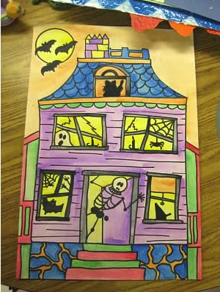
STANDARDS: National- 1,3,4; SD- 2,3,4
OBJECTIVES:
- Create art that expresses ideas or moods.
- Selecting subject matter and symbols related to Halloween to convey meaning.
- Connecting art and architecture.
- Identify the elements of art in famous works of art.

MATERIALS:
- 12”x18” white paper
- Sharpies
- Crayons
- Handouts with Victorian style house Ideas

PROCEDURE:
- Get students excited by showing them pictures of various haunted houses and mansions. Walk them through seeing various shapes, lines, colors, and patterns. What details do they notice? Broken fences, shingles, trees with no leaves, bats, owls, creaky stairs, fancy trim, windy road/sidewalk, tower, chimney, broken windows, spider webs, clouds covering the moon, pumpkins, tombstones, cracks, candles, black cats, etc. Explain that a lot of haunted houses are in the Victorian architectural style. This kind of architecture has a lot of intricate features like trim, shingles, porches, and fancy woodwork.
- Do a quick demo of how to start. Draw the tree first because it is in the foreground. Then draw the house, moon, sidewalk, any fences, pumpkins, etc. Talk about how using organic shapes for the shape of our houses, we can make our houses look spookier. Talk about adding spooky creatures like cats, bats, mice, spiders, ghosts, skeletons, etc. Demo drawing some of these.
- Tell students they must have a tree, a moon, and their house. All other details are up to them. Pass out handouts to look at for ideas on how to draw Victorian style architecture.
- They will draw with sharpie or black marker and then color with crayon. Remind them about color blending (black and purple for sky) and that their house should be a different color than the sky so it “pops” out. Emphasize coloring slowly and filling in all the white.

VOCABULARY: organic shapes, shapes, lines, texture, Victorian-style architecture, overlapping, trim

ASSESSMENT:
- Student successfully drew a haunted house using some Victorian-style architectural elements.
- Student has a tree in the foreground.
- Student has used good craftsmanship in drawing and coloring their artwork.

COMMENTS:
______________________________________________________________________________________________________________________________________________________________________

